

BOXPLOT ANALYSIS ASSIGNMENT

NAME: PERSEVERANCE MWAMBA
COURSE NAME: STATISTICAL MODELING

COURSE CODE:
Student Number:20254067
Date: 23 FEBRUARY 2026

BOXPLOT ANALYSIS USING DISCRETE DATA
Question
Using a boxplot as a Exploratory data analysis tool, determine the five Quatiles and outliers for two discrete data sets of two examples. Include diagrams.

INTRODUCTION
Exploratory Data Analysis (EDA) is a critical preliminary stage in statistical investigation that focuses on examining and summarizing the essential characteristics of a dataset prior to formal modeling or hypothesis testing. The primary objective of Exploratory Data Analysis (EDA) is to understand the structure, distribution, variability, and underlying patterns within the data. By applying both numerical summaries and graphical techniques, researchers can detect anomalies, assess data quality, identify potential outliers, and determine whether the assumptions required for further statistical analysis are satisfied.
Among the graphical tools commonly used in EDA, the boxplot (box-and-whisker plot) is particularly effective for summarizing numerical data. A boxplot visually represents the distribution of a variable using the five-number summary: minimum, first quartile (Q 1), median (Q 2 ), third quartile (Q 3), and maximum. These statistics provide insight into the central tendency and dispersion of the dataset. Additionally, the boxplot facilitates the identification of skewness and extreme observations through the Interquartile Range (IQR), calculated as:
IQR=Q 3−Q 1
​ Observations that fall beyond 1.5×IQR from the quartiles are classified as potential outliers, offering an objective criterion for detecting unusual values.
In this study, a dataset in CSV format was imported into the Statistical Analysis System (SAS) environment using the PROC IMPORT procedure. Descriptive statistics, including the five-number summary, were computed using PROC MEANS to obtain precise numerical measures of dispersion and central tendency. Furthermore, PROC SGPLOT was employed to generate a boxplot, enabling visual assessment of data distribution and the automatic identification of outliers based on the 1.5×IQR rule.

Methodology and SAS Implementation
The analysis was conducted using the following SAS procedures to ensure data integrity and statistical accuracy.

FIRST DATASET

Data Ingestion
The external CSV file was read into the SAS Work library. The guessingrows=max option was utilized to ensure SAS correctly identified the variable types (numeric vs. character).
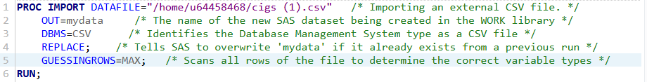

Statistical Computation
The PROC MEANS procedure was invoked to calculate the Five-Number Summary. This provides the mathematical backbone for the boxplot construction.
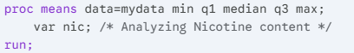

Visualization and Outlier Detection
The VBOX statement within PROC SGPLOT was used to render the boxplot. SAS identifies outliers by plotting individual markers for any data point x where:
x>Q3+1.5(IQR) or x<Q1−1.5(IQR)
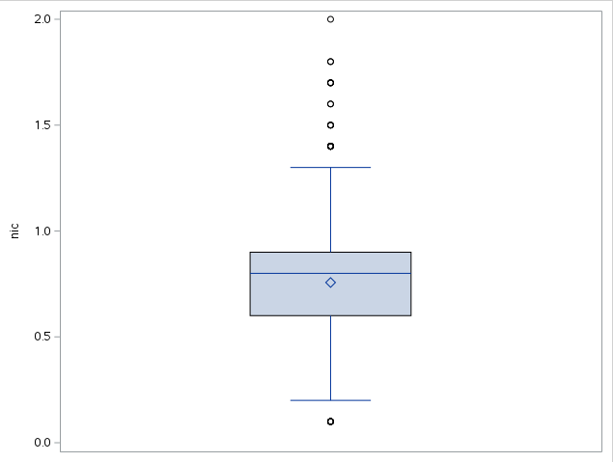
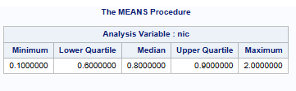
SECOND DATASET

Data Ingestion
The external CSV file was read into the SAS Work library. The guessingrows=max option was utilized to ensure SAS correctly identified the variable types (numeric vs. character).
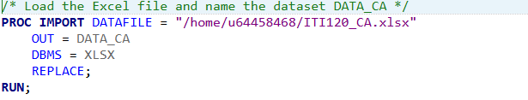

Statistical Computation
The PROC MEANS procedure was invoked to calculate the Five-Number Summary. This provides the mathematical backbone for the boxplot construction.
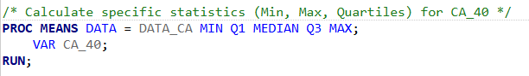

Visualization and Outlier Detection
The VBOX statement within PROC SGPLOT was used to render the boxplot. SAS identifies outliers by plotting individual markers for any data point x where:
x>Q3+1.5(IQR) or x<Q1−1.5(IQR)
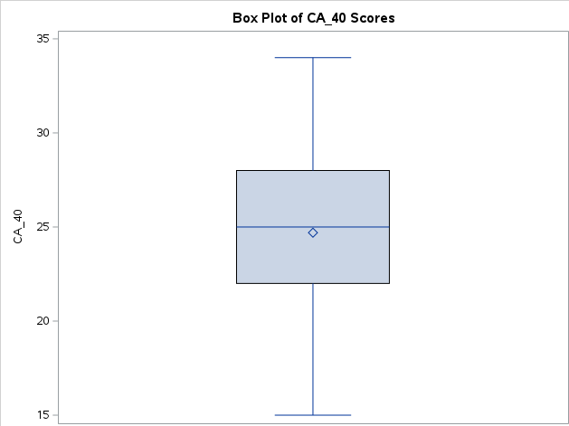

Definitions of Statistical Components
Outliers: Observations that are numerically distant from the rest of the data, often indicating experimental error or heavy-tailed distributions. In the boxplot, these are the individual points plotted beyond the whiskers. One low outlier near 0.1 and seven high outliers ranging from 1.4 to 2.0.
Minimum: The smallest numerical value in the dataset that is not classified as an outlier; it is represented by the bottom horizontal line (the end of the lower whisker).
Whiskers: Lines extending from the box to the minimum and maximum values (excluding outliers). They represent the range of the non-extreme data.
First Quartile (Q1): The 25th percentile of the data; it marks the bottom edge of the box and indicates that 25% of the data falls below this value.
Median (Q2): The 50th percentile; the value separating the higher half from the lower half of the data. It is represented by the horizontal line inside the box.
Third Quartile (Q3): The 75th percentile of the data; it marks the top edge of the box and indicates that 75% of the data falls below this value.
Maximum: The largest numerical value in the dataset that is not classified as an outlier; it is represented by the top horizontal line (the end of the upper whisker).
Conclusion
In summary, this assignment successfully utilized SAS to perform an Exploratory Data Analysis on two discrete datasets. By implementing PROC MEANS, the exact five-number summaries were calculated, providing a clear mathematical picture of the data's central tendency and spread.
The boxplots generated through PROC SGPLOT allowed for a visual assessment of the distributions and the objective identification of outliers using the 1.5 times IQR rule. For example, the nicotine (nic) dataset revealed a clear positive skew with several high-end outliers, while the carbon monoxide (CO) dataset displayed a negative skew with low-end outliers. This process demonstrates how statistical modeling tools like SAS are essential for identifying patterns and anomalies in data before further analysis is conducted.

